MVC- Model View Controller:

The MVC (Model-View-Controller) pattern is useful in Node.js applications because it helps organize code into separate layers, making it easier to manage and maintain. Here’s a breakdown of how it works and why it’s useful:

Model: This layer handles the data and business logic of the application. Models interact with the database to get, save, or update data. Separating the data logic here keeps it clean and reusable.

View: The view is responsible for what the user sees. In a Node.js app, views are often HTML templates or JSON responses for APIs. By separating the UI here, you can easily change the look and feel of your app without touching the core logic.

Controller: The controller acts as the middleman, managing the flow of data between the model and the view. When a user makes a request, the controller gets the data from the model, processes it, and then sends it to the view for display.

Why MVC is Useful in Node.js

1. Code Organization: MVC keeps the code organized into layers, so each part of the app has a clear purpose. This makes it easy to find and work on specific parts of the app.
2. Scalability: As the application grows, MVC allows developers to add more features without creating a tangled mess of code.
3. Separation of Concerns: Since each part (data, UI, and logic) is separate, you can easily change or update one layer without affecting others.
4. Reusability: You can reuse models and controllers in different views or even across projects, speeding up development.

In Node.js, using the MVC pattern can make your app easier to develop, debug, and expand over time.

Application Folder Structure:

Step 1: create 3 folders in application like model, view, controller and routes for routing as shown in screenshot.

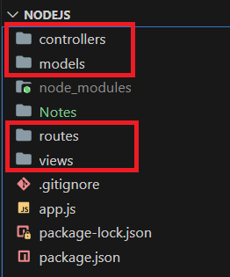

Step 2: first we create one route for first request & response so we can enter this route in browser URL and as per request we get response.

1. Step 1: in routes folder, create indexRoute.js file and write below code as shown in screenshot.

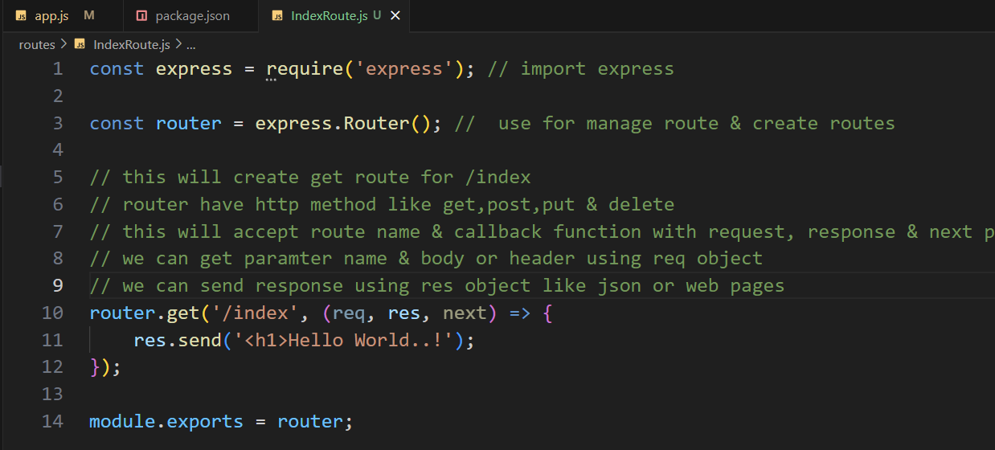

1. Step 2: register route in app.js

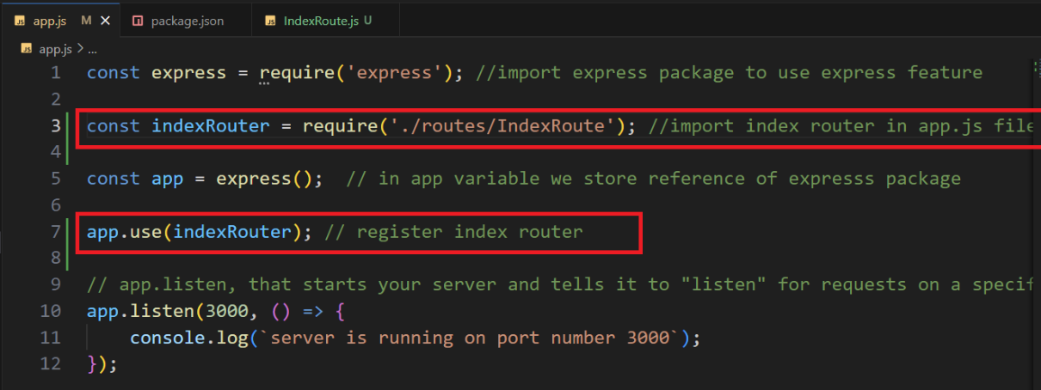

Step 3: run using npm start command in terminal & enter URL in browser as shown in below screenshot.

